
Table of Contents
1. Problem Statement 4
2. Objective of the Paper 4
3. Introduction 4
3.1 Dataset background 5
3.2 Data Summary Before Data Cleaning 5
4. Data Pre-Processing 6
4.1 Data Wrangling 6
4.1.1 Data after Cleaning in R 7
4.2 Data Simulation Process 7
4.3 Exploratory Data Analysis 9
4.3.1 Total revenue for the year 2010 and 2011 9
4.3.2 Countries with highest transactions 9
4.3.3 Most Frequent Items brought by customer 9
4.3.4 Quantity vs Unit Price 10
4.3.5 Quantity vs Unit Price 10
4.3.6 Distribution of Price for different countries 11
4.3.7 Corelation between Quantity and Total sales 12
5. Regency, Frequency, Monetary (RFM) Feature Engineering 13
5.1 RFM Metric 13
5.2 RFM Correlation plot 14
6. Algorithms 14
6.1 K-Means Clustering and Hierarchical Clustering 14
6.1.2 Scaling the data 14
6.1.3 Optimal No of Cluster 15
6.1.4 K-Means Clustering Results 15
6.2 Hierarchical Clustering 16
6.2.1 Choosing cluster across dendrogram 16
6.3 Comparison between K-Means Clustering and Hierarchical Clustering 17
6.4 Decision Tree 17
6.4.1 Pre-processing 17
6.4.2 Data Splitting 18
6.4.3 Fitting the model 18
6.4.4 Prediction 19
7. Conclusion 20
8. Limitations & Recommendation for Future Studies 20
9. References 21

Customer Segmentation Analysis & Customer Purchase Prediction

1. Problem Statement
Having an efficient marketing strategy to better target potential customers and understanding how frequently a new customer will purchase the same item are two main issue that e-commerce retailers frequently deal with. With K-Means Clustering and Hierarchical Clustering, this paper aims to introduce Regency, Frequency, Monetary (RFM) model in R programming and segment customer purchase behaviour. Making the choice of which product to stock up in advance to prevent delivery delays to customer as business expand and more clients come on board is never an easy one for business owners. This assignment also seek to predict the frequency with which a new customer will repurchase the same product using Decision Tree algorithm.

2. Objective of the Paper
- Identify which cluster is the most valuable customer that have a higher interest in the product so to develop marketing strategies for sales team.
- Generate RFM value based on a set of rules
- Compare the performance of the two models to see which outperform.
- Predict the number of purchases a new customer would make on a product of certain monetary value, based on Recency and Frequency.

3. Introduction
- Using online retail dataset was from UCI Machine Learning Repository
- A Uk based online store which sells mainly occasion gifts. Many of their customers are wholesalers.
- Data is a transnational data set which contains all the transactions occurring between 01/12/2010 and 09/12/2011 .
- Original Dataset contains 541,909 observations and 8 variables.
- Dataset Link : https://archive.ics.uci.edu/ml/datasets/online+retail

3.1 Dataset background

Variable | Data Type | Description
Invoice No | Nominal | a 6-digit integral number uniquely assigned to each transaction. If this code starts with letter 'c', it indicates a cancellation.
StockCode | Nominal | a 5-digit integral number uniquely assigned to each distinct product.
Description | Nominal | Product (item) name.
Quantity | Numeric | The quantities of each product (item) per transaction.
InvInvoicete | Numeric | Invoice Date and time., the day and time when each transaction was generated.
UnitPrice | Numeric | Unit price., Product price per unit in sterling.
CustomerID | Nominal | Customer number. l, a 5-digit integral number uniquely assigned to each customer.
Country | Nominal | Country name., the name of the country where each customer resides.

3.2 Data Summary Before Data Cleaning
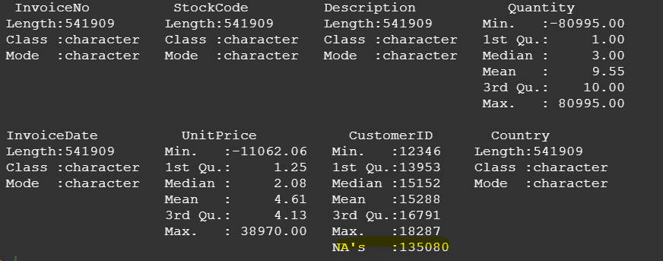
Before we proceed to do data wrangling, we see that there are 541,909 observations available in this dataset and 8 variables. There were 135,080 NA’s missing in Customer ID.
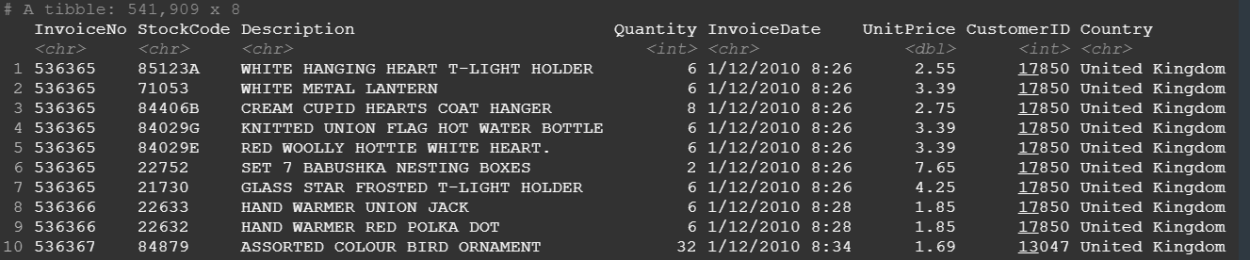

4. Data Pre-Processing

In this section, we will review data wrangling ,data that was being analysed after data wrangling, data simulation process, exploratory data analysis and RFM feature engineering.

4.1 Data Wrangling

- Split InvoiceDate to Invoice Month and Invoice Time, convert to character.
- Create New Variable that contain Month, Year
- Presence of Null Values and negative value for quantities

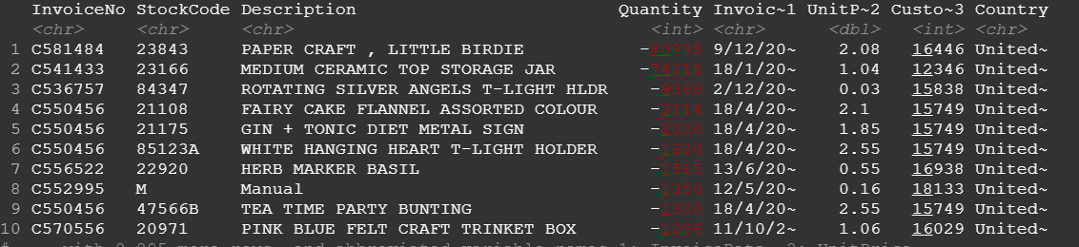

- Create new variable (Total Price)= Total Qty x unit price
- NA for Customer ID

We can see that there are a lot of CustomerIDs missing, and a very small percentage of Descriptions missing from the data. For the NAs on CustomerID we will remove them from the data since the dataset is rich enough to have a pretty large sample to serve our purpose even without the missing values which could lead to false results.
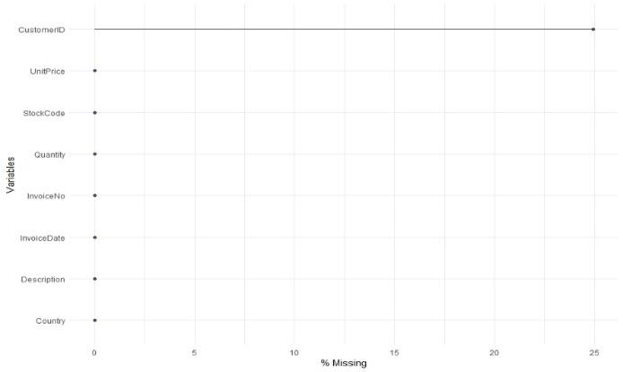

- Identify Outliers

The result of the outlier diagnosis plot shows that the dataset is reliable for further analysis.
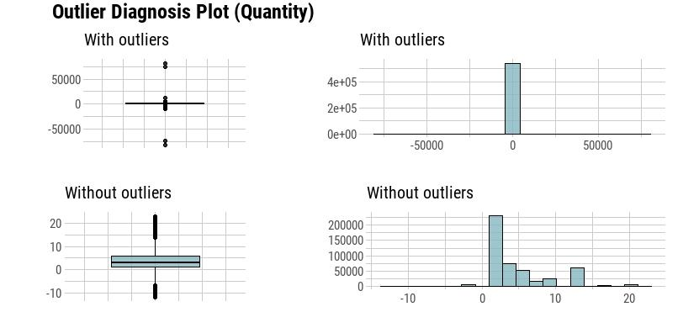

- Convert vector variable Country , Invoice No, Customer ID , Description to “as.factor” (categorical) variable.

4.1.1 Data after Cleaning in R
After data wrangling, we retained 304,720 observations and 14 variables in this dataset is use to further our analysis.
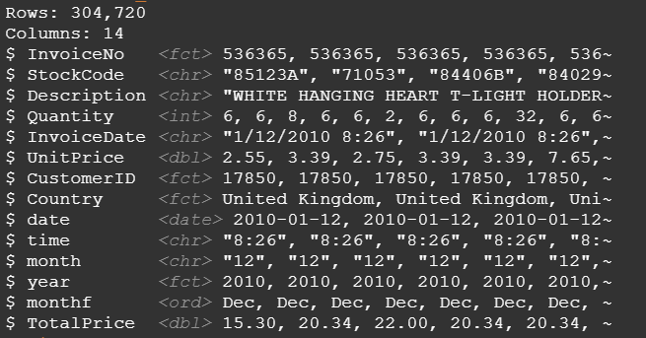

4.2 Data Simulation Process
Figure 1, gives a brief view of the data simulation process for customer segmentation analysis and customer purchase return.
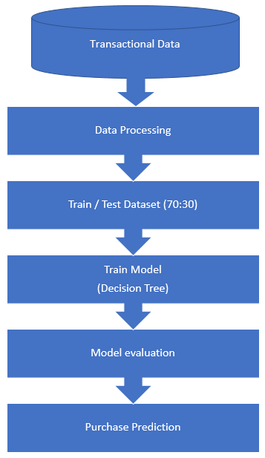
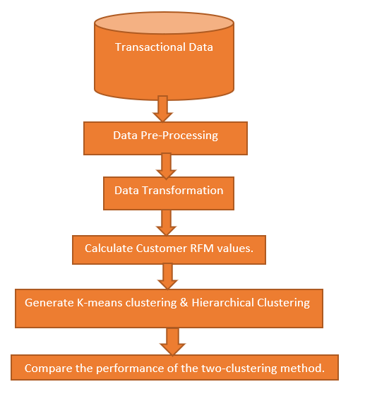
Figure 1 . Customer Segmentation Analysis & Customer Purchase Prediction Process

Customer Segmentation Analysis
Customer Purchase Prediction

4.3 Exploratory Data Analysis
This section review the total revenue for year 2010 and 2011, countries with highest transactions ,the most frequent item purchase by customer, Regency, Frequency and Monetary value (RFM) and RFM matrix.

4.3.1 Total revenue for the year 2010 and 2011
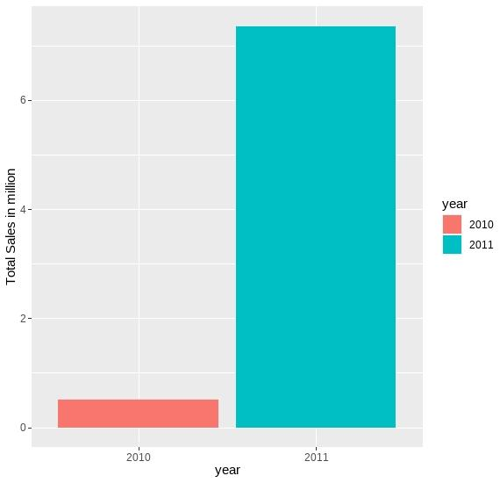
ggplot was used to visualise the revenue for 2010 and 2011.We could see that year 2011 ($7,742,795) achieved higher sale as compared to 2010 ($554,604).

4.3.2 Countries with highest transactions
The result from ggplot shows countries that generate the highest number of transactions was UK, while the lowest transactions generated was Switzerland.
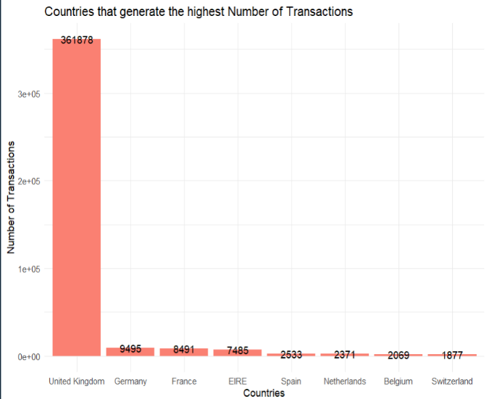

4.3.3 Most Frequent Items brought by customer
The result from ggplot shows products that was purchase frequent by customer was “White Hanging Heart T-Light Holder” and the least frequent brought by customer was “Assorted Colour Bird Ornament” .
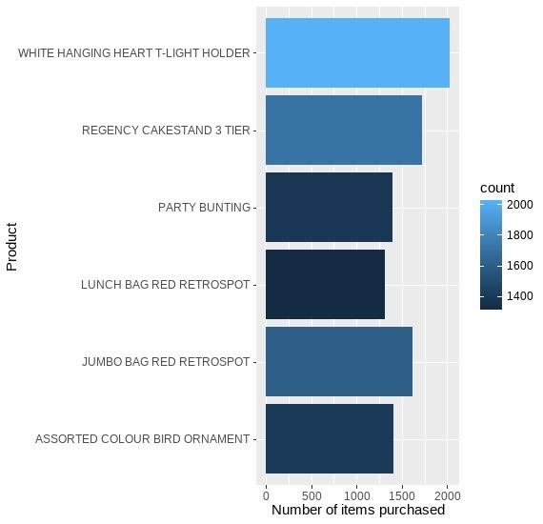

4.3.4 Quantity vs Unit Price

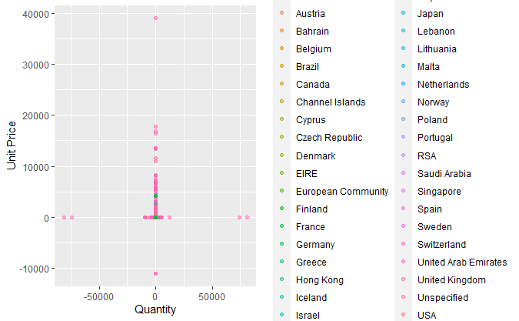
The Scatter Plot between Quantity of Items Bought and Unit price of each item. The different colour dots on the scatter plot represent different countries from where items were purchased.

4.3.5 Quantity vs Unit Price

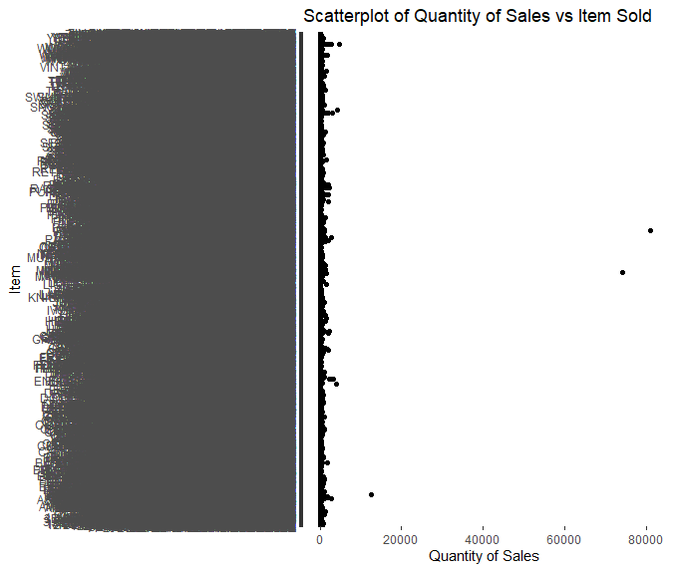
The scatter plot shows the distribution of Quantity of items sold and the name of the items on the Y axis. As there are too many descriptions, the Y axis label generated cannot fit all names and tend to appear messy.

4.3.6 Distribution of Price for different countries

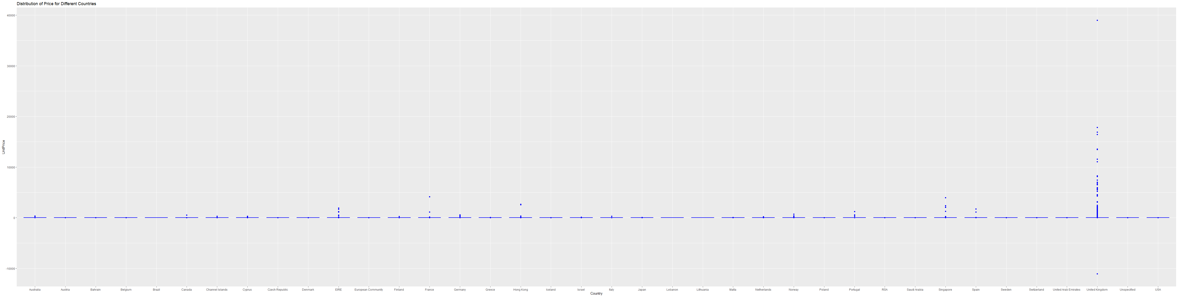
This is the box plot that shows the price distribution for Different countries from where items were bought. The name of the countries are on the X-axis and -axis represents the quantity. Most of the items were sold in UK as it is a UK based store.

4.3.7 Corelation between Quantity and Total sales
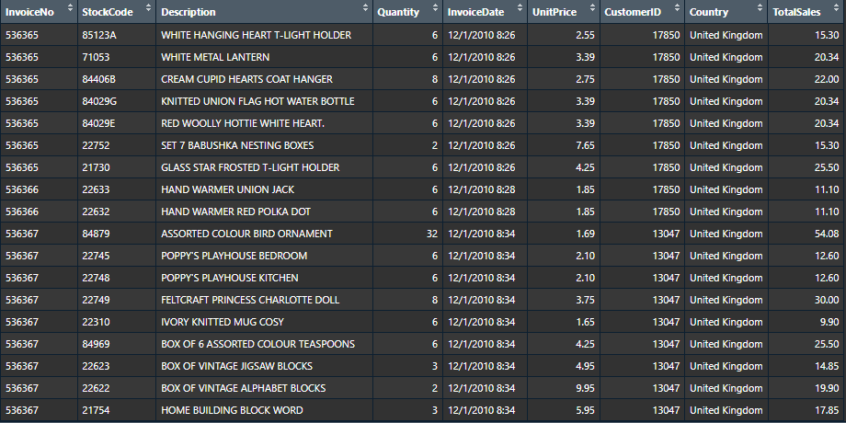

A new Column “Total Sales” was created.
Correlation was plotted using Heatmap and the Heat map result is as shown below.
The Correlation coefficient between Quantity and Total Sales tend to be 0.89
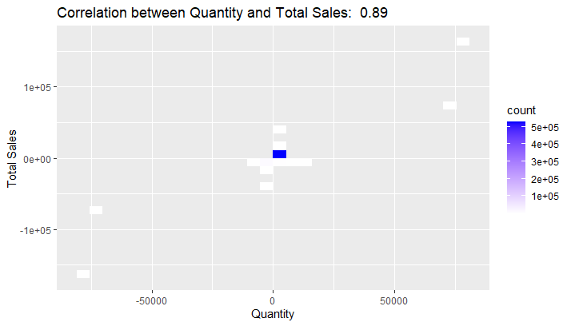

5. Regency, Frequency, Monetary (RFM) Feature Engineering

RFM analysis is a marketing approach that quantifies and groups customers based on regency, frequency and monetary total of their recent transactions in order to find the best customers and perform targeted marketing campaigns(Dogan, 2018).
RFM analyse the customer based on three factors :
- Recency refer to number of days since last purchase ; how recently has the customer has purchased . Customer who recently made a purchase will still have the product in mind and more likely to purchase the product again.
- Frequency refers to no of transactions ; How often and for how long have they purchased ? Customer who purchased once are often are more likely to purchase again. Additionally, first time customer may be a good target for marketing advertising to convert them into more frequent customers.
- Monetary refer to total amount of transaction ; How much have they purchased ?

5.1 RFM Metric

From the plots, we could see the distribution of the 3 RFM attributes.
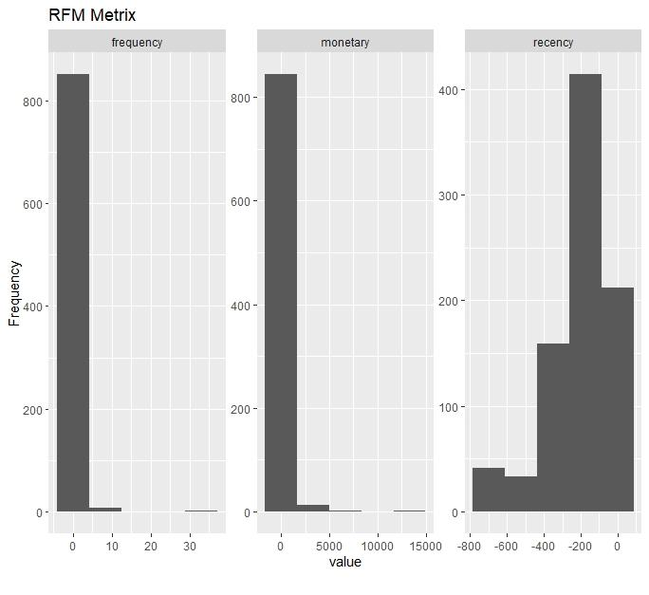

5.2 RFM Correlation plot

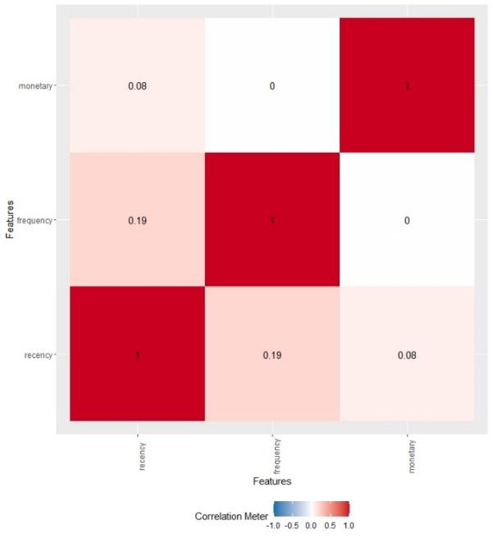
RFM correlation plot, indicates the correlation between regency and monetary has a positive weak coefficient (0.08), regency and frequency has a positive weak coefficient (0.19),monetary and recency has a positive weak coefficient (0.08) .

6. Algorithms
This section reviews the algorithms used for Customer Segmentation analysis and Customer Purchase retention. Customer Segmentation Analysis was perform using K-means and Hierarchical Clustering whereas customer purchase retention was perform using Decision Tree.

6.1 K-Means Clustering and Hierarchical Clustering

Clustering method was the most frequently used for E-commerce data(James et al., 2021).By using clustering method, it is possible to segment customer base on common interest, common lifestyle, or even demographic profiles. In order to cluster customer based on RFM values, unsupervised learning K-Means Clustering and Hierarchical Clustering was used.

6.1.2 Scaling the data

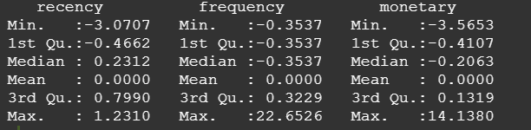
RFM data was normalise to each dimension on a comparable scale with mean 0 and standard deviation 1.

6.1.3 Optimal No of Cluster
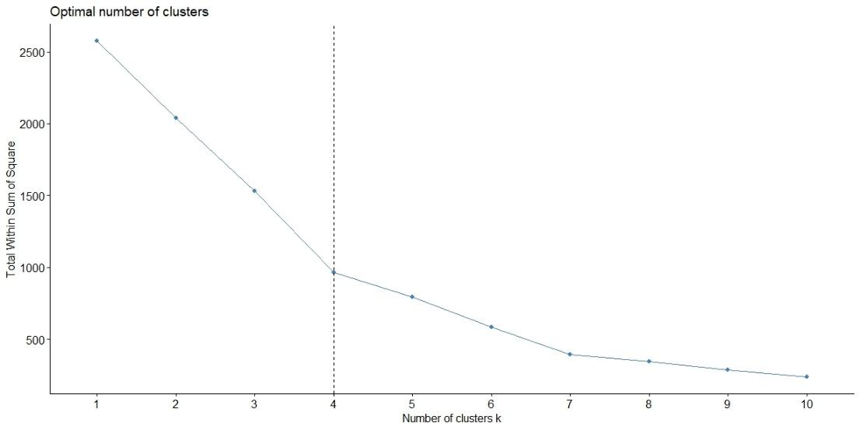
Using elbow method to get the optimal no.of cluster . From the output, the number of K = 4 .

6.1.4 K-Means Clustering Results
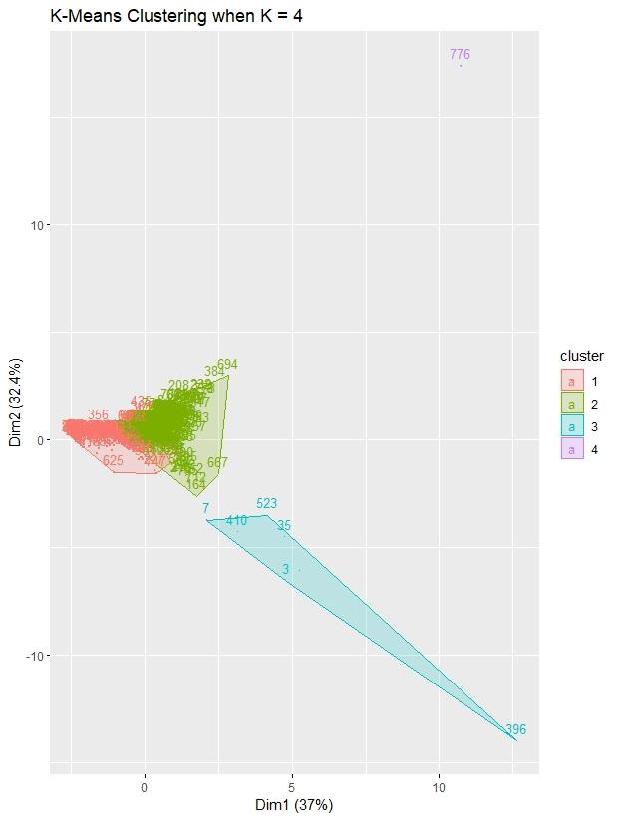
Based on RFM value, We describe the four cluster.

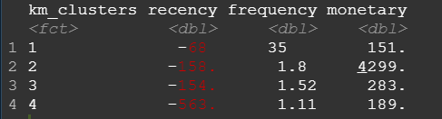

Cluster 1 :Customer with highest regency and frequency and medium monetary value. These are rather new customer . We suggest companies send emails to ensure customer remain active.
Cluster 2 : Customer with moderate recency and frequency but highest monetary value. These are champions and promising customer that must keep. Therefore, we could directly contact these customer if they are happy with the service given to them.
Cluster 3: Customer with moderate recency and frequency and moderate monetary value. These cluster of customer show medium activities but do not spend much. We advise to offer quantity discounts or time limited discount to motivate customer to spend more.
Cluster 4 : Customers with the lowest recency score (last purchase long time ago),lowest frequency, and medium monetary. Cluster 4 customers are inactive and at risk , We would advise the retailer to offer discounts or send reminders to regain customer’s attention of their product.
K-means clustering result was evaluated using Between cluster sum of Squares (BCSS) which measure the squared average distance of all the points between centroids. The score is 62.4% which is relatively good , which indicates the total variance of our data is explained by K-means.

6.2 Hierarchical Clustering

Hierarchical clustering is another alternative of clustering method.

6.2.1 Choosing cluster across dendrogram
- Compute distance matrix using Euclidean distance , and perform K =4.
- Perform using a linkage method, Complete.
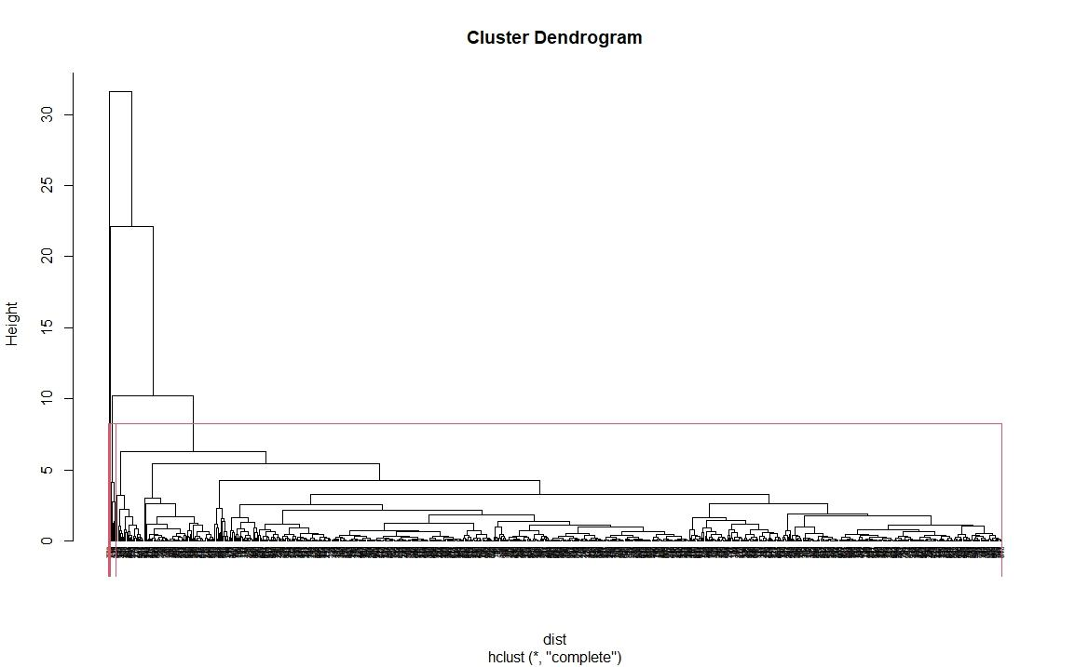

Hierarchical clustering was performed with the similar steps for K-means, optimal k = 4 .
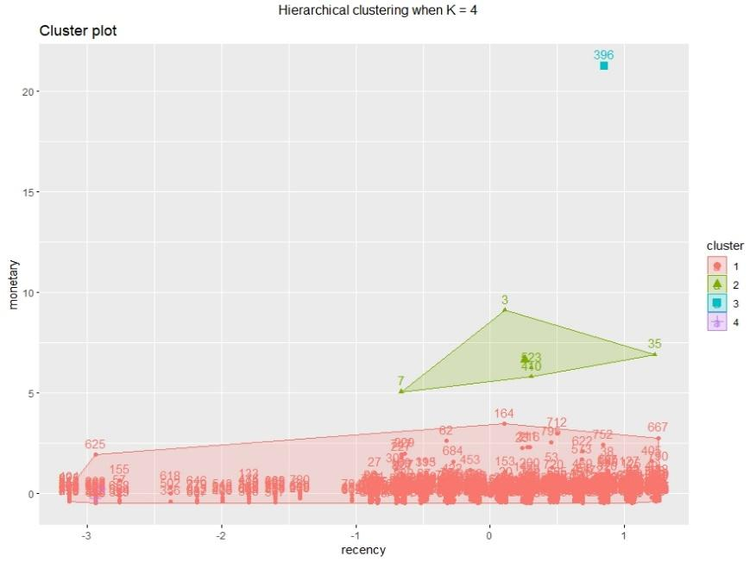

6.3 Comparison between K-Means Clustering and Hierarchical Clustering
By comparing the total within sum of squares of k-means clustering with optimal K = 4 , it seems k-means clustering outperform hierarchical clustering .

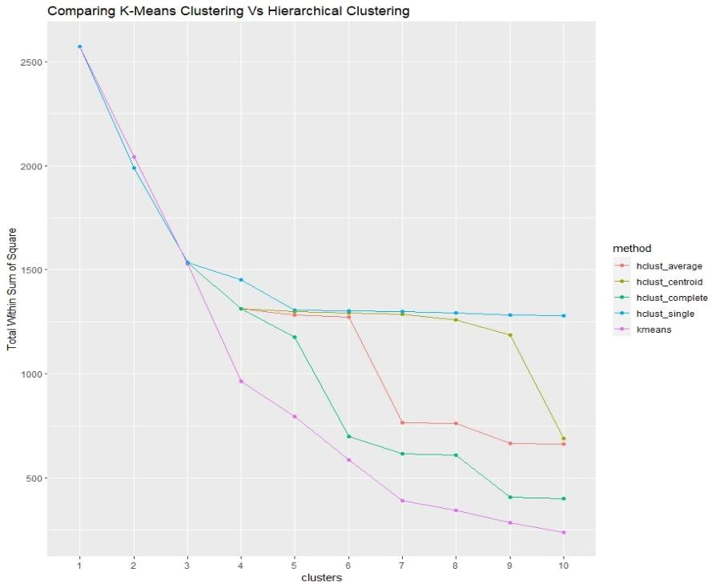

6.4 Decision Tree

The data has more than 53 categories and hence Random Forest cannot be used.
The next alternate to perform prediction analysis was Decision Tree.
Decision Tree represents a decision-making process through a branching, tree-like structure that ends in outcomes. In machine learning, the decision tree algorithm splits dataset features through a cost function, resulting in a tree-like structure that is grown and pruned to remove irrelevant or overly granular branches. Decision trees are simpler than other machine learning algorithms, making them easier to understand and interpret, but may not perform as well on complex datasets. There are different types of decision trees, such as binary decision trees, multiway decision trees, and regression trees, each with their own strengths and weaknesses depending on the specific problem being addressed (Klaise, 2021).

6.4.1 Pre-processing

Data Pre-processing is important before fitting the model.
filter(!is.na(CustomerID)) – this command is to Remove rows with missing customer ID
mutate(InvoiceDate = as.POSIXct(InvoiceDate) - This is to Convert InvoiceDate to POSIXct format.

After pre-processing, the dataset would have 406829 observations of 6 variables
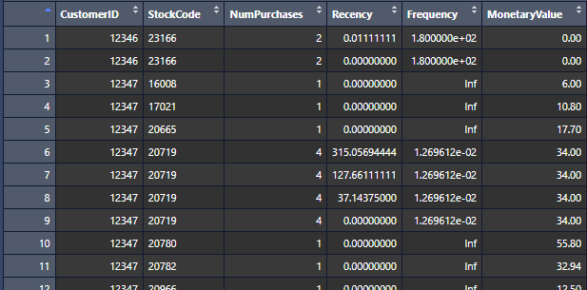

6.4.2 Data Splitting

The Data was Split into training and testing data on 70:30 basis.
Train Dataset has a total of 284780 observations of 56 variables.
Test dataset has a total of 122049 observations of 6 variables.

6.4.3 Fitting the model

The next step would be to fit the decision tree model for the train data.

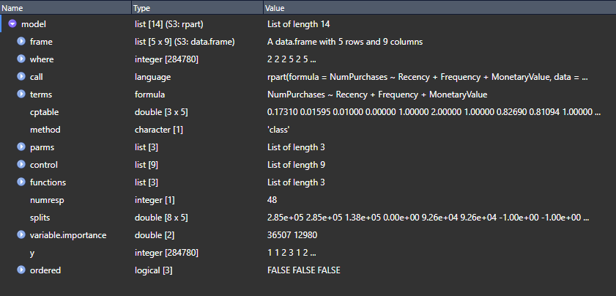
By plotting the Decision tree model below plot has been generated
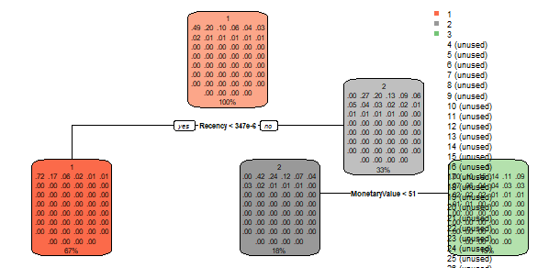
Next is to find the accuracy of the model. By running R script, the accuracy obtained for the model tends to be 0.59 = 59%.
The accuracy obtained for both Train Data and Test data seems to be 59%.

6.4.4 Prediction

R script to Predict the number of purchases for a new customer and product of cost $100 and a recency of 60 days and a frequency of 0.1
new_customer <- data.frame(Recency = 60, Frequency = 0.1, MonetaryValue = 100)
prediction <- predict(model, new_customer, type = "class")
print(paste0("Predicted number of repeated purchases: ", prediction))
the output for the below script is:
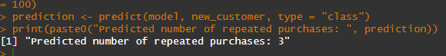
With the help of this model, it is easier for Business owners to find out how many times a new customer would repeatedly purchase a product, that costs ‘X’ $, recency of ‘Y’ days and Frequency of ‘Z’.

7. Conclusion

In this paper, Customers were grouped according to their regency, frequency and monetary values. We compared the performance of K-means clustering, and Hierarchical Clustering. K-means clustering perform better because it focuses specifically on minimising the within sum of square measure.
Algorithms can help business segment their customer base, tailor their marketing campaigns to their customer based on their purchasing habits and concentrate their efforts on building stronger bonds for a more profitable future. With the help of Algorithm, we are able to predict the number of purchases a new customer would make on a product of certain monetary value based on recency and frequency.

8. Limitations & Recommendation for Future Studies
RFM modelling can provide useful information about customers. However, it does not consider customer demographics such as age, income, sex , education and ethnicity. Furthermore, the dataset used does not contain this information. Future research could combine customer demographic data and RFM scores to predict customer lifetime value.
Regularly evaluate and updating the prediction models would be highly recommended to ensure that they are accurately reflecting changes in the online retail environment.

9. References

Dogan, O., Aycin, E., & Bulut, Z. A.,. (2018). CUSTOMER SEGMENTATION BY USING RFM MODEL AND CLUSTERING METHODS: A CASE STUDY IN RETAIL INDUSTRY. INTERNATIONAL JOURNAL OF CONTEMPORARY ECONOMICS AND ADMINISTRATIVE SCIENCES vol.8, 1-19.
James, G., Witten, D., Hastie, T., & Tibshirani, R. (2021). Unsupervised Learning. In G. James, D. Witten, T. Hastie, & R. Tibshirani (Eds.), An Introduction to Statistical Learning: with Applications in R (pp. 497-552). Springer US. https://doi.org/10.1007/978-1-0716-1418-1_12
Klaise,J. (2021). Decision Tree in Machine Learning. Seldon Blog.
https://www.seldon.io/decision-trees-in-machine-learning

